|  |  |  |  |
| --- | --- | --- | --- |
| Name |  | Date |  |

1. Draw the symbol for the following schematic types;

|  |  |
| --- | --- |
| Normally Open Temperature Switch |  |
| Normally Closed Pressure Switch |  |
| On delay timer Switch |  |
| Normally Closed Float Switch |  |
| Double-Acting Pushbutton |  |

1. The acronym PLC stands for;
   1. Programmable Ladder Control
   2. Programmable Logic Computer
   3. Program Ladder Configuration
   4. Programmable Logic Controller
2. How are PLC inputs protected?
   1. Through the use of surge suppression
   2. Fuses
   3. Opto-isolation
   4. They aren’t
3. In an Allen-Bradley PLC, what does XIC mean?
   1. Examine if Closed
   2. A normally open contact
   3. Not “made”
   4. All of the above
4. In the following program, what is the value of C?

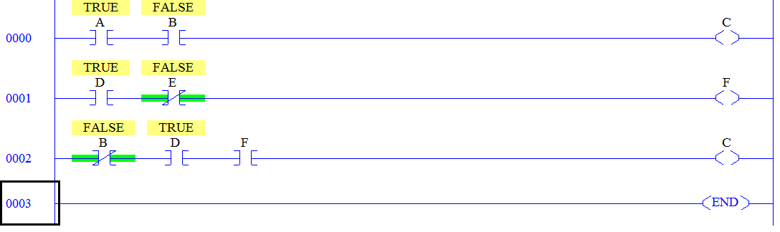

1. Complete the truth table for the following PLC program.

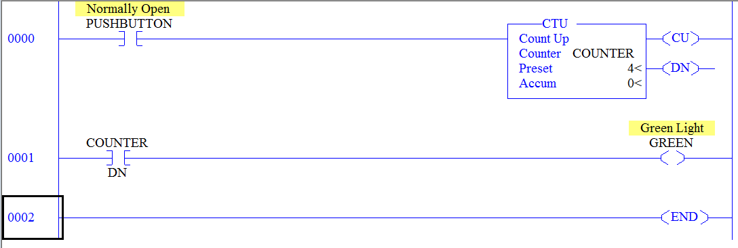

|  |  |  |  |  |
| --- | --- | --- | --- | --- |
| SCAN | PUSHBUTTON | COUNTER/ ACCUM | COUNTER/  DN | GREEN |
| 1 | 0 | 0 | 0 | 0 |
| 2 | 1 |  |  |  |
| 3 | 0 |  |  |  |
| 4 | 1 |  |  |  |
| 5 | 0 |  |  |  |
| 6 | 1 |  |  |  |
| 7 | 0 |  |  |  |
| 8 | 1 |  |  |  |

1. Fill in the following tables;

|  |  |  |  |  |  |  |  |  |  |
| --- | --- | --- | --- | --- | --- | --- | --- | --- | --- |
| Position | 8 | 7 | 6 | 5 | 4 | 3 | 2 | 1 | 0 |
|  | 28 | 27 | 26 | 25 | 24 | 23 | 22 | 21 | 20 |
| Place |  |  |  |  |  |  |  |  |  |

|  |  |  |  |
| --- | --- | --- | --- |
| Position | 2 | 1 | 0 |
|  | 82 | 81 | 80 |
| Place |  |  |  |

1. Convert the following numbers.

001 101 1102 to _______________10

3710 to _______________________2

578 to _______________________10

32710 to _____________________bcd

1. Relay coils operate on either ______________ or _______________?
2. Time delay relays are either ____________________ or __________________?
3. Why are relays used in control circuits?
   1. You can control many devices with one signal
   2. It isolates lower control voltage from higher operating voltage
   3. Separates higher amperage circuits from control logic
   4. B and C
   5. All of the above
4. Solid state relays are?
   1. Expensive
   2. Not used as often as other types of relays
   3. Sealed from contaminants
   4. Quiet
   5. C and D
   6. A thru D
5. What two main components make a Motor Starter? _______________ and ____________
6. Draw a start/stop motor control schematic using a NO pushbutton, a NC pushbutton for inputs. When the motor is on, the green light shall illuminate. When the motor is off, the green light shall be off and the red light shall illuminate. You have a standard 8-pin (Ice cube) relay to control power to the single phase motor. Additionally, the circuit should have a “master-kill” switch that does not allow the motor to operate and turns off the red and green lights. When the circuit is in the “master kill” state, the yellow light shall be on. Ensure that all rung numbers, terminal numbers, wire numbers, cross-references and supply voltages are included.

|  |  |  |  |  |  |  |  |  |
| --- | --- | --- | --- | --- | --- | --- | --- | --- |
|  |  |  |  |  |  |  |  |  |
|  |  |  |  |  |  |  |  |  |
|  |  |  |  |  |  |  |  |  |
|  |  |  |  |  |  |  |  |  |
|  |  |  |  |  |  |  |  |  |
|  |  |  |  |  |  |  |  |  |
|  |  |  |  |  |  |  |  |  |
|  |  |  |  |  |  |  |  |  |
|  |  |  |  |  |  |  |  |  |
|  |  |  |  |  |  |  |  |  |
|  |  |  |  |  |  |  |  |  |
|  |  |  |  |  |  |  |  |  |
|  |  |  |  |  |  |  |  |  |

1. For each example given below, complete the truth table, write out the formula, and state the type of logic each rung represents.

|  |  |  |  |  |  |  |  |  |  |  |  |  |  |  |  |  |  |  |  |  |  |  |  |  |  |  |  |  |  |  |  |  |  |  |  |  |  |
| --- | --- | --- | --- | --- | --- | --- | --- | --- | --- | --- | --- | --- | --- | --- | --- | --- | --- | --- | --- | --- | --- | --- | --- | --- | --- | --- | --- | --- | --- | --- | --- | --- | --- | --- | --- | --- | --- |
| |  |  |  | | --- | --- | --- | | Rung 1 |  | | | START1 | START 2 | M | | 0 | 0 |  | | 1 | 0 |  | | 0 | 1 |  | | 1 | 1 |  | | |  |  |  | | --- | --- | --- | | Rung 2 |  | | | START1 | START 2 | M | | 0 | 0 |  | | 1 | 0 |  | | 0 | 1 |  | | 1 | 1 |  | |
| |  |  |  | | --- | --- | --- | | Rung 4 |  | | | STOP 1 | STOP 2 | M | | 0 | 0 |  | | 1 | 0 |  | | 0 | 1 |  | | 1 | 1 |  | | |  |  |  | | --- | --- | --- | | Rung 6 |  | | | STOP 1 | STOP 2 | M | | 0 | 0 |  | | 1 | 0 |  | | 0 | 1 |  | | 1 | 1 |  | |



1. Identify the parts of a relay.
   1. _____________
   2. _____________
   3. _____________
   4. _____________
   5. _____________

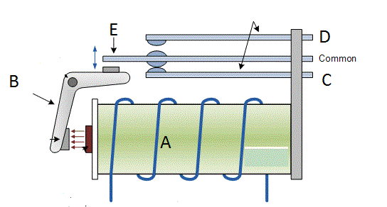

1. Without seeing any more of the schematic below, can CR be an 8-pin relay? Why or why not.

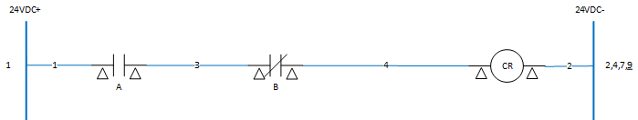

1. Complete the truth table below for the given schematic.

|  |  |  |  |
| --- | --- | --- | --- |
| START | STOP | OL | M |
| 0 | 0 | 0 |  |
| 1 | 0 | 0 |  |
| 0 | 1 | 0 |  |
| 1 | 1 | 0 |  |
| 1 | 1 | 1 |  |



1. Write the formulas for the following wires and output.

Wire 3 = ___________________________________

Wire 4 = ___________________________________

M = _______________________________________

1. Which overload method is used for large current drawing motors?
   1. Bimetal strip
   2. Solder Melting
   3. Magnetic
   4. None of the above